OPERATION MANUAL

GZL-80 liquid filling machine
（FOR 1/2/4/6/8/10 FILLING NOZZLES NEWEST MODEL)

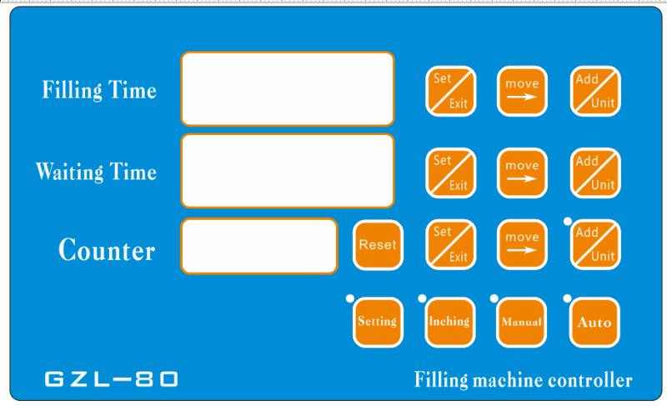

1 Overview
1.1 scope of application
Control liquid filling machine is the use of microcomputer for micro pump in the filling time, motor speed and other factors on the control, achieve uniform, repetitive error minimum liquid filling method, widely used in pharmaceutical, chemical, food, beverages, oils, cosmetics and other industries, is suitable for low viscosity, no-granules liquid filling, small batch production.
By the way, the gear pump can stand the high temperature and foamy liquid. And it is up to the food class. The diaphragm pump mode only can stand below 75 degree liquid with weak corrosion.
As for peristaltic pump filler model,it can be widely used more. Almost all the easy flow of liquid can filling, particularly suitable for sanitary conditions require very high nutrient solution, biological agents, chemicals and pollution, toxic, corrosive liquid filling;
Technical parameters
Voltage AC220V Carton size 350 * 400 * 180 ( MM )
Power 80W Weight 5KG
Filling scope ML- 000ML Maximum suction distance 1.5M
Maximum flow rate of L / MIN
Repetitive error smaller than 0.5% （depending on the density of product)
Performance characteristics
1. Equipped with microcomputer-controlled chips with precise control and easy operation.
2. Digital display, precise and free from parallax.
3. Touch panels, comfortable hand touch and good sensitivity.
4. Data saving function in the chips.
5. Large filling range. For small pump machine, it is adjustable from 0.5ml to 3000ml; for large pump machine, from 10ml to 150,000 ml
6. The whole body is made of stainless steel.
*Attention: Firstly ,turn on the machine, You could clear the air inside the inlet silicone tube and pump by pressing the “inching” button on the left of control panel until the air is clear ,then stop pressing and there is liquid out from the filling nozzle.This button can also be used for cleaning the machine quickly.
You could go on following operation after getting out the air of the inlet silicone tube and pump.
This point is very important for gear pump and diaphragm pump model. Please leave some clean water inside the pump after working ,especially you won’t use the machine for a long time. It can extend the lifetime of the pump effectively.( because it can avoid working without any liquid and can protect the gears inside pump effectively.)
2.1 Control panel introduction
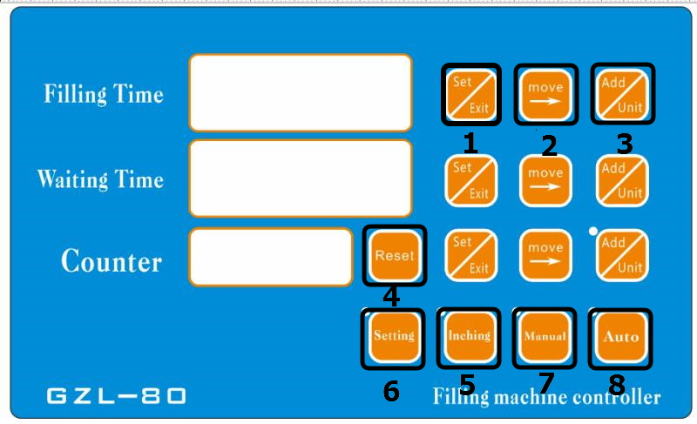
*Button function introduction:
1,Set/exit button:Press it one time to set the filling/waiting time in the standby state. And can exit the setting mode if you press it one time again.
2,Move button:Move the cursor from left to right or to opposite direction
3,Add/unit button:Can adjust the setting number from 0-9 circularly
4,Reset button:Can restart the filling count from 0
5,Inching button:Can pull out the air inside the silicone tube and pump by pressing it in the standby state before filling.You also can press it to pull all the liquid out of the silicone tube and clean the machine conveniently.
6,Setting button:You can set your needing filling volume roughly by pressing it with 2 times.
- Manual button:You can make the machine filling with foot pedal or pressing it. One time ,one filling.
- Auto button:The machine will fill automatically based on the setting time
- Add/mode: It shows the working mode
- Increase/decrease button: You can adjust the filling speed from 0-99 .The speed is faster if the number is bigger.
3.Operation example
Firstly,Please let the machine stop filling .or please ensure that the machine is in standby/stop state by press” auto ” key.((The machine will enter the standby station ,if you press “auto” key one time when it works with the automatic mode.The “auto” indicator will be off)； Secondly,adjust the filling time and waiting/interval time,filling speed.
1, Usually, The count doesn’t need to be adjusted. But you could return it to “0”,when the machine is in standby state by pressing “reset” key.
2, As for the time meaning: we usually set “01.00” when you start the machine. It shows the relative filling time and waiting time. It means 1 second. 00.10 means 0.1 second. 10. 00 means 10 seconds
But if you move the point by pressing the “add/unit”, its meaning will change. Such as : 010.0 it means 10 seconds ,001.0 it means 1 second, 1000.0 it means 1000 seconds
They are the same meaning for the filling and waiting time
- Now ,we will set you an example to prove it . such as ,we want to fill the water with weight about 50g.(We take the 5L model as example)
We know the machine’s max filling speed is about 5000ml per min in the max state. It will be smaller if we install the filling nozzle and filters. So we could conclude that the max filling weight is about 70ml per second for reference. So we could adjust the filling speed to the max and adjust the filling time to “01.00” by pressing” set/exit” key to choose the relative time,then move the “move” key to choose the relative number, then press “add/unit” key to change the number from “0-9” circularly ( The adjustment is workable only for the blinking number). We press the “set/exit”key again, then the blinking number will stop and be stored in program after pressing “reset/exit” button again.
The waiting time is only workable in the state of automatic. And the time between 2 fillings is shorter,if you want to fill efficiently.
4, we could choose automatic mode or manual mode(by press relative key to choose) after setting the time.
Automatic mode means the machine will work according to the setting filling and distance time circularly ,unless you press the “auto”. You could press action mode to start filling if you choose the required mode.
Manual mode means the machine will work only when you press the “manual” button or press” foot pedal”.it will fill one time when you press one time. The machine will not work if you don’t press.
(There are all the details of the control panel in the description of product ,please let me know, if you have any further questions)

Stop it
Start
Time of arrival
Interval timer
Delay time arrival
Filling time
Automatic

（Move in circles）
）
4.Maintenance
Clean the filter periodically .or the debris and small granules will affect the accuracy of filling .
If it is found that the pump motor can be workable, but no water or flow becomes very small, there maybe a pump body full of impurity, disassemble the pump, check if the gears were blocked by them, lastly ,clean them and tighten the screw pump cavity.
Only professional personnel can disassemble the machine. During maintenance work, you must be strictly observed to maintain attention, otherwise it can not guarantee the safe operation of the machine.
5 packing list
The power cord 1pcs ; filling bracket 1set; anti-drop nozzle 1pcs ; the inner six angle wrench - M6 1pcs and operation manual ,1pcs.

