《ZS-1810 User Manual》
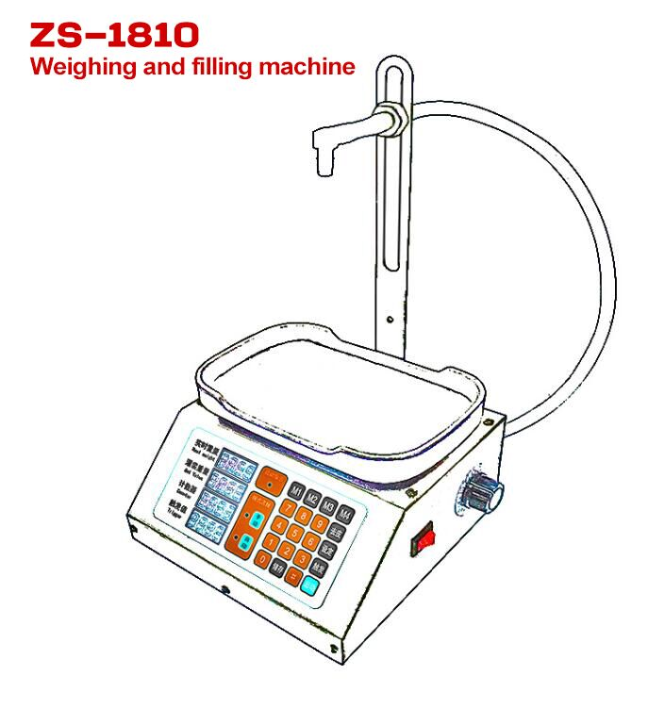
First, technical indicators
- Power supply: AC110-220V, 50-60hz, power: 30W
- Maximum weighing: 4kg, dividing value: 1g
- Display characteristics: Weight window 4 digits, Set window 4 digits, counter window 4 digits, trigger window 4 digits
- Features: real-time weighing, overload alarm, automatic counting, automatic start, automatic frequency conversion, automatic stop, Filling data storage, delay adjustment, error correction and other functions.
- Ambient temperature: store -10℃ to 60℃, work 0 to 50℃

Second, the display window and button function description
1. Display window:
Weight (g): displays the actual weight of the item being weighed
Set (g): User-set weight to be filled
Counter (bottle): number of bottles that have been filled
Trigger (g): the weight value that triggers the auto start
2. Button function:
[Man ] key: Enter manual mode
[Auto] key: enter automatic mode
[Tare] key: peeling, clearing function
[Set ] key: set the filling weight
[Trig] key: set the trigger value
[Run ] key: manually start the filling function (click again to pause)
[Save] key: store 4 groups of commonly used filling data
[M1-4] key: Call the stored filling weight data
[ 0 ] key: Counter value is cleared

Third, the operating instructions
1. "Set value" setting method:
Press the [Set] key to enter the value (for example, set 500g, enter 5 0 0), and then press [Set] again.

2. "Trigger value" setting method: (trigger value can not be less than 3 grams)
Press the [Trig] key, enter the value (for example, set 35g, enter 3 5), and then press [Trig] again.
Note: The trigger value is set to ≤ empty bottle weight.In automatic mode, the automatic filling is triggered when the weight of the empty bottle exceeds the trigger value.

3. "Manual mode" operation method: (Press the [Man] key, the manual light is on, enter the manual mode;)
(1) Put the empty bottle, press the [Tare] button to remove the empty bottle weight, press the [Run] button to start the filling.The weight of the poured liquid reaches the set filling weight and stops automatically.
(2) Remove the filled bottle, put down an empty bottle, press the [Tare] [Run] button to start the next filling.
4. "Automatic mode" operation method: (Press the [Auto] key, the automatic light is on, enter the automatic mode)
Put the empty bottle, the system automatically peels and automatically starts filling after a delay of x seconds.When the weight reaches the filling weight, the filling is automatically stopped.Remove the filled bottle and the system will automatically reset to zero after a delay of x seconds.Put the next empty bottle and automatically start the next filling.
Note: When using the automatic mode, if the machine is not properly filled, it is because of a mistake caused by a cycle not end yet.At this point, remove the bottle and press [Tare] to use it normally.

5.The setting method of “storing 4 groups of filling weights to M1-M4”:
Press the [Save] key (the number of filling weights starts to flash), input the value to be stored, and finally press the [M1] key (the number of “filling weight” stops flashing) and the number to be entered is stored in M1. When you need to use the value of m1 as the filling weight, you can press m1 to set the value of m1 as the filling weight. (Set M2, M3, M4 as the method of setting M1)

6. How to cancel the automatic peeling function :(refers to the automatic peeling
function in automatic mode)
Restart the machine, press the [Auto] button, and then hold down the [3] button until you hear the alarm sound of the machine and let go. At this time, the automatic peeling function has been cancelled. If you want to turn on the automatic peeling function, repeat the above operation. Once set up, the machine will remember forever.

7. In the automatic filling mode, the default delay between the loading of containers and the automatic peeling is 0.8 seconds, which can be reset by the customer according to the actual needs. The range can be set: 0.1-9.9 seconds. The setting method is as follows :(Non-professionals, please do not set this item!)
restart the machine, press [Auto] [Set]in order, and then input value (input range is 1 ~ 99, 1 on behalf of 0.1 seconds, 9.9 seconds 99 delegates, beyond the scope of the number is invalid), and then click the "set", in the end, hold down the number keys [1] don't let go until hear machine alarm to let go, completes the set. Once set up, the machine will remember forever.

8. In the automatic filling mode, when the weight reaches the filling weight, the filling is automatically stopped and the full bottle is removed. The default time delay between "remove the full bottle" and "system automatic reset to zero" is 0.8 seconds. Customers can reset it according to their actual needs. The range can be set: 0.1-9.9 seconds. The setting method is as follows :(! Non-professionals, please do not set this item!)
restart the machine, press [Auto] [Set] successively, and then enter the value with the number key (the input range is 1-99, 1 represents 0.1 second, 99 represents 9.9 seconds, and the number beyond the range is invalid), then press [Set], and finally press the number key [2] and do not let go until you hear the alarm sound of the machine. Once set up, the machine will remember forever.

9. How to set the "The value of slow down": (Non-professionals, please do not set this item!)
Press the [Trig] [Save] button (a new number will flash), then enter the value to be set (the system defaults to 8), and then press [Trig] again.

Fourth, the use of the speed control knob
1. This product comes with a speed control knob. The 0-100 on the dial represents the adjustable range from small to large.
2. When the filling volume is less than 30g, it is necessary to adjust the flow rate appropriately to achieve the most accurate effect;
3. When the filling amount is more than 30g, it is generally adjusted to the maximum flow rate.

Five, product characteristics
1. The container to be filled cannot be a bag, it must be a bottle that can stand on its own, and the diameter of the bottle mouth is not less than 1 cm;
2. Applicable capacity: It is recommended to use within 2000g (=2000mL water) for filling;
3. Applicable liquid: pure liquid, no impurities, no thick, no corrosive;
4. Maximum flow rate: 3500 g / min (= 3500 mL water / min).

Sixth, about water absorption
When the machine is used for the first time, the phenomenon of non-absorbent water is normal, because the interior is dry for a long time.The treatment method is: add some water from the inlet pipe, and then click the [Run] button, or directly suck it from the outlet pipe after starting.

